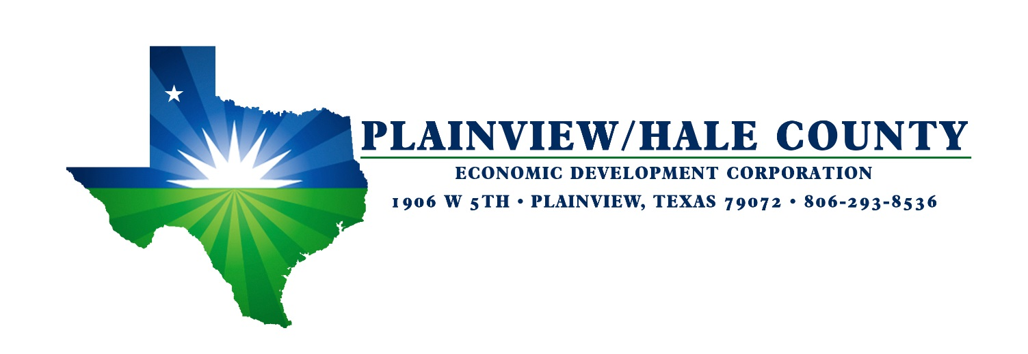
About Plainview-Hale County
- Plainview, Texas MSA 38,380 in population
- Inviable Logistics. Located in the center of the United States, Plainview is easily accessible from the East and West Coasts with Interstate 27 connecting to Interstate 40 within an hour’s drive. Hale County Airport features a 6,000 ft. LED lighted main runway and a 4,000 ft. LED lighted cross wind runway. Available rail served by Burlington Northern-Santa Fe with 8 trains daily, including a 100+ acre wind-turbine distribution center.
- Wayland Baptist University and South Plains College-Plainview Branch.
- Covenant Hospital-Plainview. Recent 40-million-dollar renovation and expansion.
- 45 miles from Lubbock, Texas and 70 miles from Amarillo, Texas, both with populations over 200,000 and each with International Airports.
- Low taxes. Texas is business friendly with no personal income tax, no state property tax or unitary tax.
- Inexpensive Energy. Companies in Plainview-Hale County enjoy electric and natural gas rates that are among the lowest in the nation.
- Hale County is #7 nationally in Cotton Production.
Who we Are
Plainview, Texas is the home to 22,000 residents and is the county seat of Hale County, population 36,000. Plainview has 51 churches, educational opportunities, cultural offerings for all ages include the Plainview Symphony. Plainview Country Club and Civic Center features an 18-hole golf-course and banquet facilities for large groups.

Hale County has long been one of the top agriculture producing counties in the U. S. In 2018, Hale County led the nation in cotton production. While agriculture provides the economic base, manufacturing, food processing and distribution facilities have added diversity to the local economy.

Walmart Distribution and Transportation Center, our largest employer has been in Plainview since 1986. Their facility spans 1.2 million sq. ft. with over 20 miles of conveyor belts. Azteca Corn Milling was established in 1989 and is the largest corn flour mill in the world.

Significant Employers
Walmart Distribution and Transportation Center/Walmart Supercenter – 1,500
Plainview Independent School District – 750
Texas Department of Criminal Justice – 450
Wayland Baptist University – 350
Covenant Hospital – 320
Azteca Milling – 300
City of Plainview – 212
Hi Plains Millwright - 61
Gebo’s Distribution – 50
Larson Manufacturing – 49

Recent News
On the horizon is the official opening of the 160 acre “shovel ready” Plainview-Hale County Business Park. The first tenant, Western Equipment is constructing a 43,000 square foot facility to house their John Deere dealership, regional service center and parts warehouse. The company plans to add 20 new jobs over the next 5 years.

Incentives
Tax Abatement programs through the City and County are available. Plainview-Hale County EDC cash incentives may apply based on number of employees, hourly wage and capital invested.
Additionally, we can assist with providing information on qualifications for available incentive programs offered by the Texas Governor’s office of Economic Development.

Contact
Michael Fox, Executive Director
Plainview-Hale County Economic Development Corp.
1906 West 5th St.
Plainview, TX. 79072
(806) 293-8536
Email: Michael.fox@plainviewedc.org

Plainview’s central location with its excellent Interstate and highway infrastructure, an affordable and available labor force, low taxes and low cost of living make Plainview-Hale county worthy of serious consideration for your business and industry.

